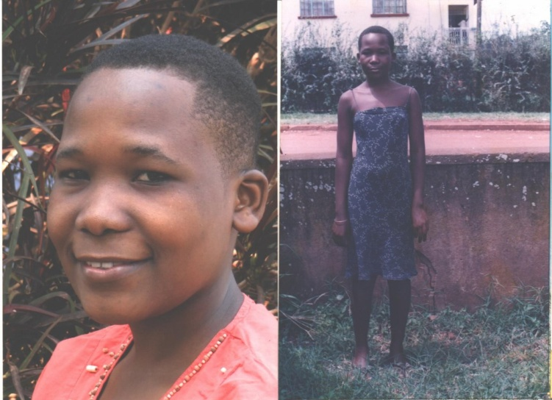

**PROSSY NANGOBI**

Her Father died when she was just five and the mother passed on two years later. She was left in the hands of her step mom who had many children to look after and was also sick and weak. The community leaders informed us about her condition and we visited the home. We found the children in a sorry state. We took her on and the others were referred to other orginisations.She is now in senior five and aspiring to become an air hostess.

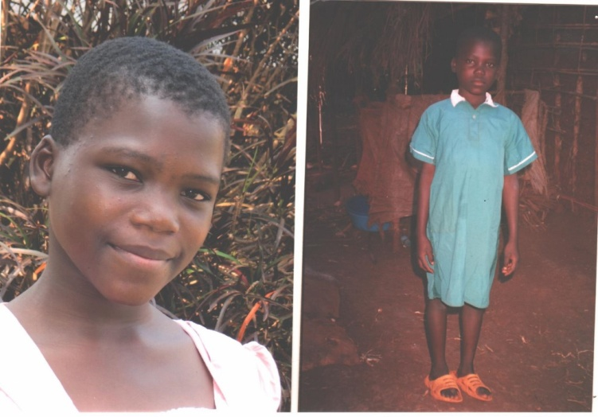

**JANE NANGOBI**

She was living with a mother who was involved in prosistitution and living in a single room with all her children. She would bring in different men in that room where she lived with her children. The community got concerned and informed the probation officer, who later contacted me. The other children were also resettled in other foster homes. She is now in primary six

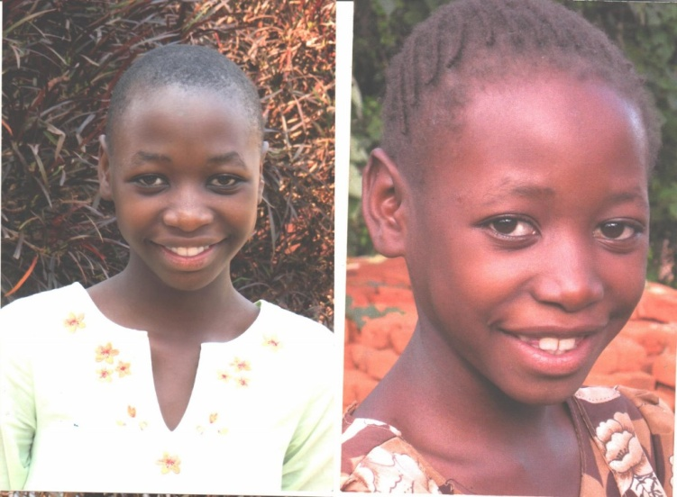

**JERRY ALITUBERA**

Lost her mother to Hiv/aids plus her her aunties who had taken her on. Remained with a frail weak grandmother who later passed on. Was brought to our attention by a friend who had attended grandma’s burial. We took her in and is now in Primary six.

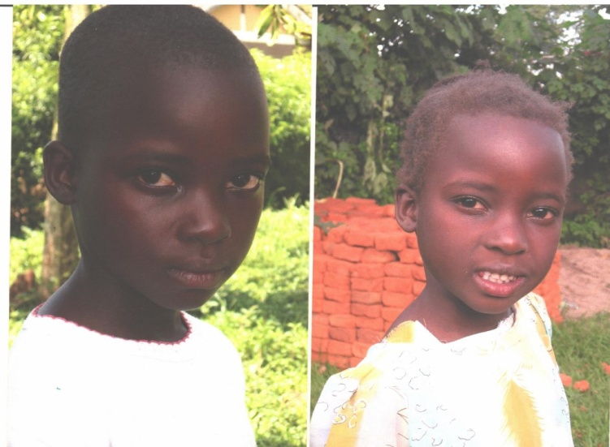

**ESTHER NAKATO**

Mother passed away while giving birth. She was brought to us by her grandfather. She is now in primary five.

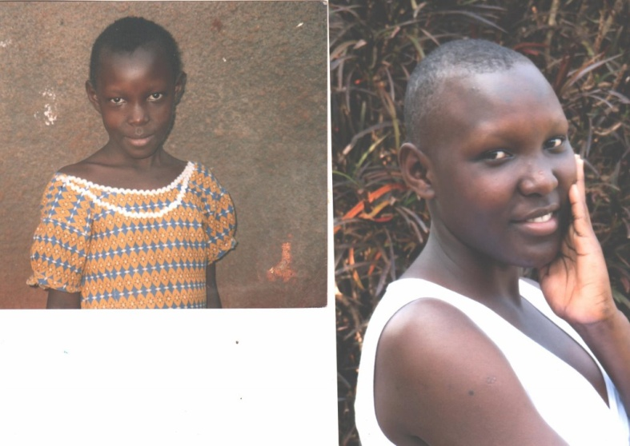

**ZAINA GRACE NAMUTEBI**

Lost both her parents to Hiv/aids. Stayed with grandparents who had many grandchildren to take care of. Anyway they too passed on. Was brought to us by an organization we net work with. We took her on and now she is in senior three.

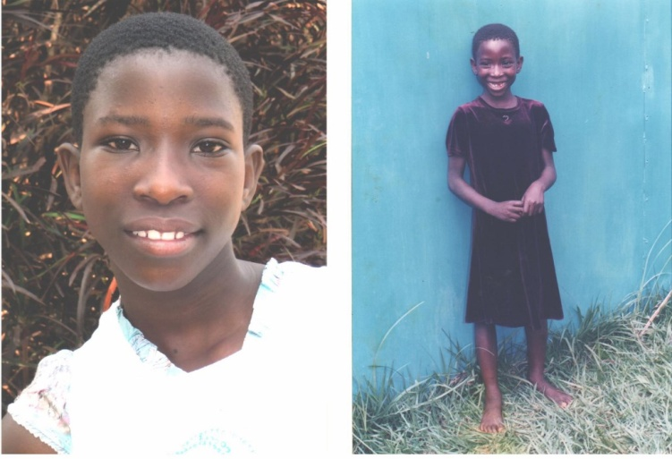

**RACHEAL TUMUSHABE**

parents to Aids epidemic. Lived with an auntie who mistreated her thinking she too was HIV positive. Was rescued by a neighbor who through the probation officer requested we take her on. She is now in primary six

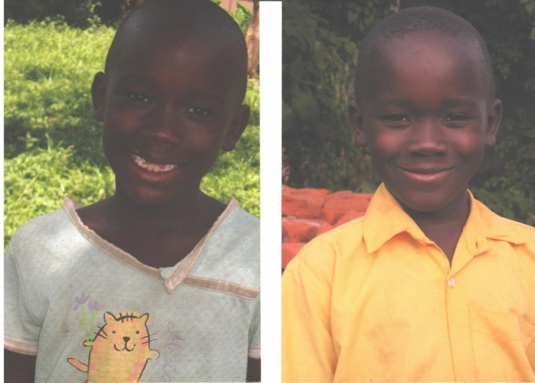

**JOHN OTINGA**

The Father abandoned the mother when she was pregnant. The mother was frustrated, would over drink and was very abusive to the boy. He was brought to us by a Good Samaritan and we took him on. He is now in primary five. The father later died while he was with us.